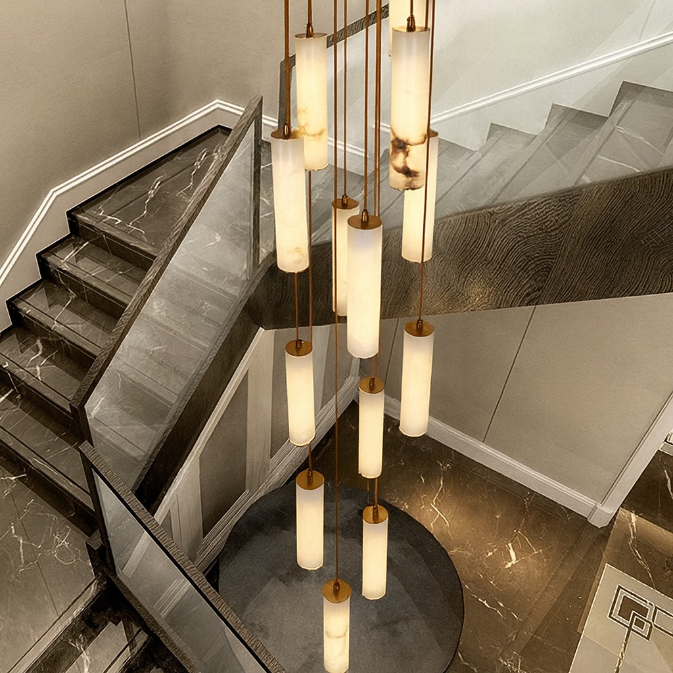
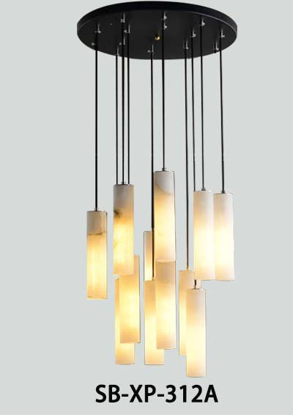

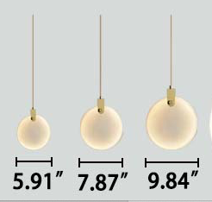

PRODUCT DESCRIPTION
Breckenridge Natural Spanish Alabaster Pendant
A sleek cylindrical pendant crafted from natural alabaster, showcasing soft veining and a warm, diffused glow. Its minimalist form and gentle illumination add refined elegance to kitchens, hallways, and modern hospitality spaces.
Breckenridge-D-3

FEATURES
• 5-year limited warranty.
• Ships assembled.
• 360 Degree.
• Alabaster cylinder, diameter 3.15", height 13.8"
• Fixture lumens per watt ratio 80 LPW.
• Natural Alabaster, Metal finishes: Aged Brass, Black Jack, Platinum Silver, Gloss White.
• More 50 lbs must be installed using a U.L. listed outlet box or supported independently
of the outlet box.

SPECIFICATIONS
• 90+ CRI.
• Input: 120-277V, 50/60Hz.
• 0-10V dimming standard, ELV / TRIAC, Dali, DMX, ZigBee available.
• UL listed, suitable for dry location. (BAA) Buy American compliant.
• Built in color temperature selectable. Choose from 3000K/3500K/4000K
Or 2700K/3500K/4000K.

Breckenridge Collection
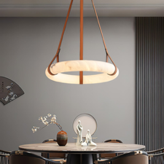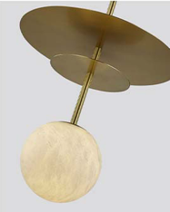
Ceiling lights Drop Pendant
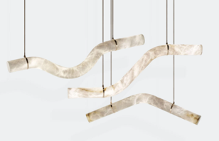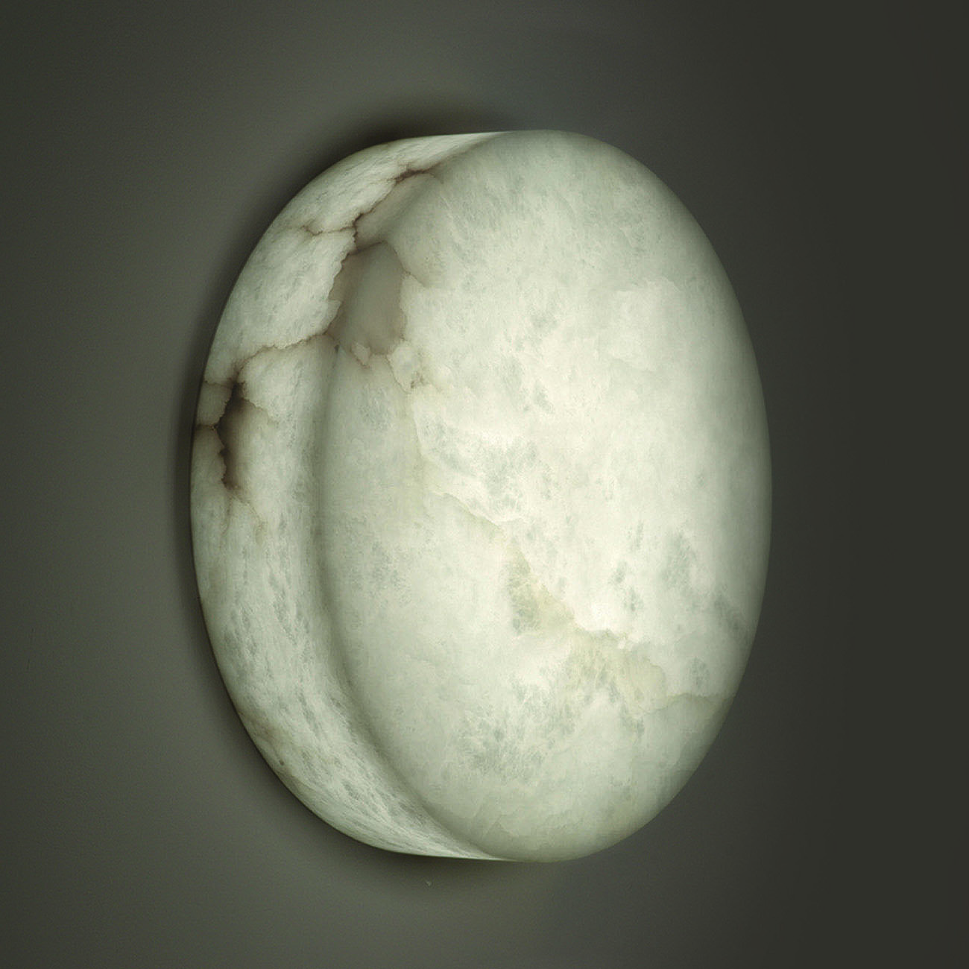
Linear Pendant Wall Sconce
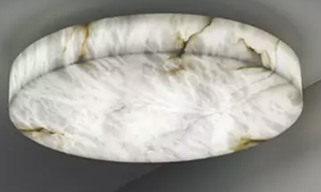
Flush Mount

PARTS PACKED WITH STANDARD FIXTURE
• Plastic Anchors, Screws, Wire Connectors
• CCT Selector Switch
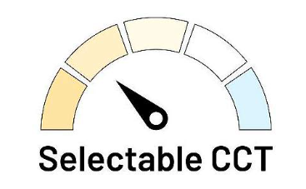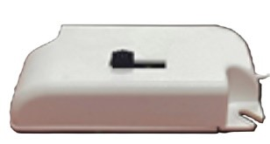

Modifications: Consult the factory for all modification requests including
• Different layouts, configurations.
• Different sizes, different quantity options for the lights
• Different metal finishes.
• Different mounting options.
• Different LED bulb base types
• Color temperatures. lumen outputs, RGBW, Tunable White available.

MODEL INFORMATION: Example: SB-XP-312A60WSA

Products Series | Wattage/Size | “E” Kelvin temp options | “W” Controls (don’t select this column if selected S or A) | “Z” Metal Finishes | “X” Aircraft Cable
*SB-XP-312A | *60W=12 Light | *S=3000K/3500K/4000K Color Select by internal CCT Color Selector, 4000K factory color default set, CRI 90 | *Blank=1-10V dimming (default) | *A=Aged Brass | *Blank=10’ foot 120” (default)
*SB-XP-312A | *60W=12 Light |  | C= Dali | *A=Aged Brass | 5’=5 foot 60”
*SB-XP-312A | *60W=12 Light | A=2700K/3500K/4000K Color Select by internal CCT color Selector, 4000K factory color default set. CRI 90 | D=DMX  (for RGBW and Tunable White, control by Wall Switch or DMX control system) | B=Black Jack | 15’=15 foot 180”
 |  |  |  |  | 20’=20 foot 240”
*SB-XP-312A | *60W=12 Light | T=3K-4K Tunable White control by remote/wall control | Z=ZigBee (for RGBW and CCT Tunable / dimmable using remote, App and Google Alexa voice. | S=Platinum Silver | 25’=25 foot 300”
*SB-XP-312A | *60W=12 Light | R3= RGB+3000K | L=ELV / Triac dimming | W=Gloss White | 30’=30 foot 360”
*SB-XP-312A | *60W=12 Light | R4=RGB+4000K | L=ELV / Triac dimming | W=Gloss White | 30’=30 foot 360”
Please request specialty pricing for alternative Kelvin temperatures, additional sizes, customizable configurations, specialty color finishes, variations in aircraft cable length, and available controls. |  |  | See control options | Find page 3 for custom color options or select from website Color Collections

STANDARD COLOR FINISHES
EMERGENCY BATTERY OPTIONS

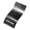
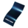
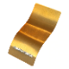

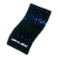
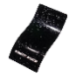
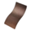
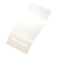
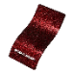
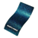
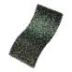
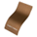
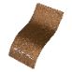
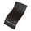
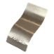
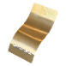
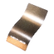
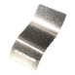
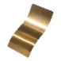
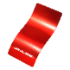
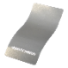
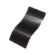
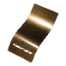
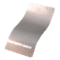
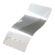
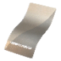
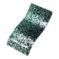
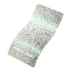
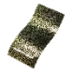
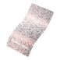
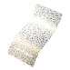
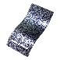
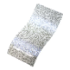
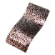
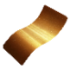
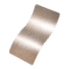
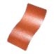
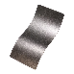
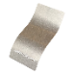
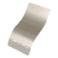
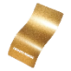
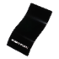
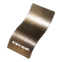
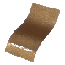
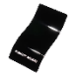
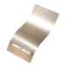
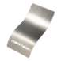

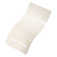
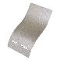
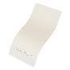
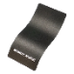
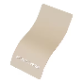

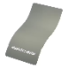
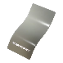
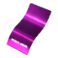
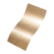
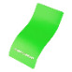

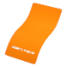

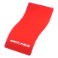
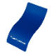
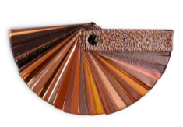
PMB-2750
Dark Grey
Sparkle

PMB-6769
Deep Blue
Sparkle

PPB-4499
Gold
Sparkle

PMB-4417
Baby Blue
Sparkle

PPB-5004
Ultra Blue
Sparkle

PPB-4727
Silver
Sparkle

PPB-5835
Rockstar
Sparkle

PMB-4130
Pearl
Sparkle

PPB-4694
Super Red
Sparkle

PPB-5078
Magnum Blue
Sparkle

SPARKLE FINISH
PWB-2590
Wetstone
Emerald II

PWB-9157
Wetstone
Gold Bronze

PWB-9156
Wetstone
Copper

PWB-2343
Wetstone
Rock Bronze

PWB-2232
Wetstone
Black

WETSTONE WRINKLED TEXTURE FINISH
PPB-5633
Tinted Clear
PPB-2262
Anodized Gold

PPB-8034
Melted Bronze

PPB-6325
Metallic Clear

PPS-6530
Brassy Gold

PPB-5936
Anodized Red

UMB-10815
Brass Chrome
PPB-6677
Black Chrome III

PMB-4124
Bronze Chrome

UMB-10813
Rose Chrome
UMS-10671
Super Chrome
Plus

UMB-10816
Copper Chrome

CHROME/SPECIALTY FINISH
PVB-10269
Dark
Palleon Panther

PVB-10273
Palleon Panther

PVB-10267
Dark Palleon
Golden Green

PVB-10272
Palleon Fire

PVB-10271
Palleon
Golden Green
PVB-10268
Dark
Palleon Paradise
PVB-10274
Palleon Paradise

PVB-10268
Dark
Palleon Fire

PALLEON METALLIC TEXTURED FINISH
SHIMMER/ GLITTER FINISH
PPB-8167
Trans Glitter
Gold
UMB-2062
Shimmer Gold

PMS-5677
Shimmer Copper

PMB-6611
Shimmer Black
PMB-5567
Champagne
Shimmer

PMB-6762
Alloy Glitter
SOLID TONE FINISH
EMS-0940
Spanish Gold
USS-2603
Gloss Black

UMB-0336
Metallic Bronze

UMB-0493
US Bronze

PPS-0106
Ink Black

PMB-0808
Performance
Gold

PMB-6525
BMW Silver
PMB-0593
Soft White
PSB-8051
Dirty White

PMB-0513
Silver Metallic II
PMB-4364
Pearl White
HSS-1336
Silk Satin Black
PSS-4647
Beach Tan
PSS-1670
Rosette Pink

PSS-4008
Jewel Grey

PSS-4500
Crest Grey

PPB-2846
Purple Glaze

PMB-5478
Montana Gold
PSB-5945
Bright Green
PSS-2876
Orange Glow
PSS-1791
JuJu Orange
PSS-0118
Spring Yellow
PSS-4971
Very Red
PMB-10657
Yama Blue
Discover beyond our standard hues with over 6,500 finishes and colors available for your luminaire, including precise color matching, NFL team colors, and custom RAL finishes. Elevate your design with metallic, sparkle, or transparent textures for a touch of individuality. Explore our most popular selections below and contact our factory for personalized quotes.
You can request color swatches by emailing us at customerservice@snowball-inc.com
Please note: Colors may appear differently due to screen display settings.

LUMEN OUTPUT

Model Number | Size | Wattage | Kevin | Lumen
SB-XP-312A60W | 12 Light | 60W | 2700K/3000K/3500K  4000K/5000K | 4800

EMERGENCY BATTRY OPTIONS SEE SPEC

PICTURE | MODEL NUMBER | DESCRIPTION
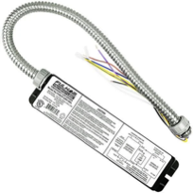 | SB-EBP/5W/B | Factory installed Remote Emergency Battery Pack 5W 90 minutes
 | SB-EBP/10.7W/B | Factory installed Remote Emergency Battery Pack 10.7W 90 minutes
 | SB-EBP/17W/B | Factory installed Remote Emergency Battery Pack 17W 90 minutes

RGBW/TUNABLE WHITE SMART CONTROL SEE SPEC AND VIDEO


Get Smart
Using Amazon Echo, Echo Dot, or any Alexa-enabled device allows you to turn your luminaire on and off, dim the light and change light color to Red, Green, Blue or White independently by using voice command or Smart phone app, DMX, Handheld remote or wall control.

DIMENSIONS & WEIGHTS: Canopy Size for ZigBee & DMX: 15.75” x 2.76”

SB-XP-312A


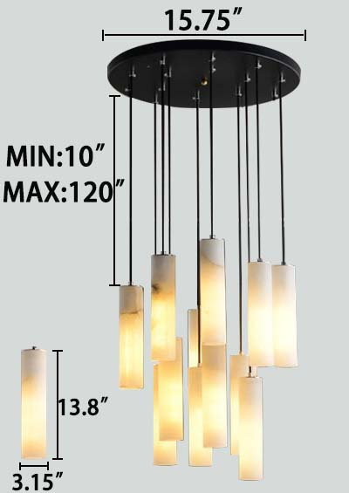

110.0 lbs

